ISRM 2027 – The World’s Largest Rock Mechanics & Rock Engineering Congress
Held only once every four years, ISRM Congress is the world’s premier and largest international gathering in rock mechanics and rock engineering.
Join over 2,000 experts from 70+ countries in vibrant Seoul, Korea, to explore cutting-edge innovations shaping a sustainable future in rock mechanics and rock engineering.
📍 Venue: COEX, Seoul, Korea
📅 Dates: October 16–23, 2027
📢 Call for Abstracts: NOW OPEN! (Deadline: Nov 30, 2026)
🌍 ISRM Country Quota Lifted
Starting from ISRM 2027, there will be no limit on the number of papers submitted from each country.
🔗 Visit Website: www.isrm2027.com
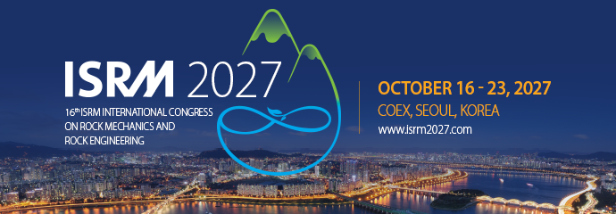
📄 Download Brochure: Call for Abstracts

