**ARMA SDC 2025 REPORT**

BY **INSERT YOUR TEAM’S NAME HERE**

LastName1_FirstName1, LastName2_FirstName2, LastName3_FirstName3, LastName4_FirstName4, LastName5_FirstName5 (Enter the details of your team members)

# paper preparation guidelines

These instructions have been created using the report template to illustrate the correct format for the preparation of ARMA SDC 2025 reports. This document uses highlights and other text decorations for emphasis, but such text decorations should not be used in the reports.

## Report submission

All reports must be submitted by **April 11, 2025, 16:00 CDT** by email to [armastudentcouncil@gmail.com](mailto:armastudentcouncil@gmail.com) with cc to [vrkarnati@etu.uqac.ca](mailto:vrkarnati@etu.uqac.ca). Please ensure that your document meets the formatting guidelines before submitting. Please submit your file as a **.pdf (PDF) document**. **There will not be any extension on the deadline** and further, late submission of the reports will not be allowed at any cost. The timeline should be respected for consideration in the evaluation. The document should not be password protected.

## Length

The preferred length of a report including text, figures, tables, acknowledgements and references (if any) is **EIGHT (8) pages**. However, there is **no formal limit** on the number of pages, provided content and consistency are maintained.

## Font

All text must be 11-point Times New Roman font with the following exceptions:

* The heading ARMA SDC 2025 REPORT must be 18-point Bold Arial font.
* The following words “BY TEAM’S NAME” must be 11-point Arial font. The team’s name must be placed in bold letters.
* The names of team members should be 11-point Arial font.
* Tables, table and figure captions use 10-point Times New Roman font.

## Page size and margins

The supplied MS Word template has been formatted per this document. If you are not using MS Word, please select “letter” paper size (215.9 mm by 279.4 mm or 8 1⁄2 inch by 11 inch) and portrait orientation – **A4 format is not acceptable**. Please set your page for the following margin dimensions: top - 25 mm, bottom - 25 mm, left - 20 mm, right - 20 mm, and gutter - 0 mm. The header and footer settings should both be set at 0 mm from the edge. In case of insertion of tables or figures requiring landscape orientation, use section breaks to introduce the landscape orientation between the pages oriented in portrait orientation.

## Page numbers

Please insert page numbers at the bottom of the page with right alignment as shown in this template.

## Spacing and Indenting

All text elements should be single-spaced. Text should be in one (1) column format. If there is a discrepancy between the template and these instructions, the instructions take precedence.

## Number headings

All sections and sub-sections must be numbered in Arabic numerals. Within the paper, number all headings as follows:

1 PRIMARY HEADING

1.1 Secondary heading

*1.1.1 Tertiary heading*

## Tables

Number tables consecutively in order of appearance and locate them close to the first reference to them in the text. Refer to tables as Table 1 or Tables 1 and 2, in the body of the text. Avoid abbreviations in column headings (other than units).

Type the caption above the table to the same width as the table. Indicate units in the line immediately below the heading.

Table 1. Sample tables with values

|  |  |  |
| --- | --- | --- |
|  | 1 | 2 |
| 3 | 571 | 86 |
| 4 | 107 | 100 |
| 5 | 113 | 125 |
| 6 | 161 | 176 |

1insert your footnote here

## Equations, formulas, symbols and units

Type equations and formulas from the left of the column (do not centre in the column) and number them consecutively. Equation numbers should be placed flush at the right column margin in parentheses. Refer to equations in the body of the text by these numbers (e.g., "Eq. 1" or "Equation 1 shows...").

Symbols should conform to the standard recommendations. In case of introduction or usage of symbols representing a different context, it should be stated in the report.

Example of equation:

τ = σ tan φ + c (1)

## Illustrations/figures

All illustrations must be embedded in the document. Please resize the inserted object to the desired final dimensions before inserting in the document in order to minimize the file size of the final document. Please number illustrations (whether drawings or photographs) consecutively in the order of appearance and refer to them as Fig. 1, Fig. 2 to 4, etc. Lettering should be approximately the same size as the text with a minimum of 2 mm. Lines should preferably be 0.2 mm thick. Captions should be placed immediately below the illustration.

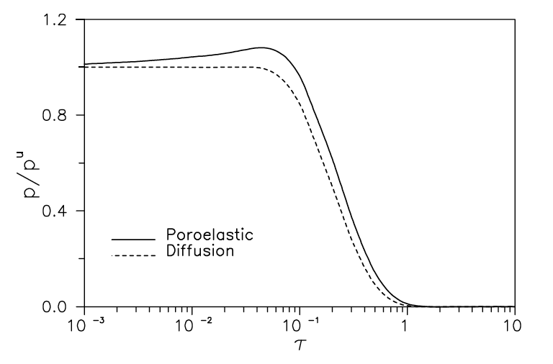

Fig. 1. Normalized pore pressure history for a pressurized cylindrical borehole, displaying the so-called Mandel-Cryer effect (Detournay and Cheng, 1993).

# references

Citation should follow the style of Author-year with the bibliography formatted according to the style of APA (American Psychological Association). Below a few examples of how journal articles, a book, a chapter in a book and a published paper in proceedings, e.g., Hoek and Bieniawski (1965), Haimson and Fairhurst (1967), Detournay and Cheng (1993), Crouch and Starfield (1983), Zoback et al. (1989), Hazzard et al. (2000), Ciardo and Lecampion (2021), and Madyarov et al. (2021), are formatted in the references.

In the list of references, the citations are listed in alphabetical order. References must be in 10 pt. Times New Roman. APA 7th Edition is recommended if you choose to use the build-in style in EndNote or other citation management tool for MS Word.

1. Ciardo, F. and Lecampion, B. (2021). Aseismic slip propagation in fractured rock masses driven by pore-fluid diffusion. In *Proc. 55th US Rock Mechanics/Geomechanics Symposium*, Houston, TX. American Rock Mechanics Association.
2. Crouch, S. L. and Starfield, A. M. (1983). *Boundary element methods in solid mechanics*. George Allen & Unwin, London, 1st edition.
3. Detournay, E. and Cheng, A. H.-D. (1993). Fundamentals of poro-elasticity. In Fairhurst, C., editor, *Comprehensive Rock Engineering*, volume 2, pages 113–171. Pergamon, New York.
4. Haimson, B. and Fairhurst, C. (1967). Initiation and extension of hydraulic fractures in rocks. *SPE J*., 7(03):310–318.
5. Hazzard, J. F., Young, R. P., and Maxwell, S. C. (2000). Micromechanical modeling of cracking and failure in brittle rocks. *J. Geophys. Res. Solid Earth*, 105(B7):16,683–16,697.
6. Hoek, E. and Bieniawski, Z. T. (1965). Brittle fracture propagation in rock under compression. *Int. J. Fract*. *Mech*., 1(3):137–155.
7. Hoek, E. and Martin, C. D. (2014). Fracture initiation and propagation in intact rock–a review. *J. Rock Mech. Geotech. Engng.*, 6(4):287–300.
8. Madyarov, A., Prioul, R., Zutshi, A., Seprodi, N., Groves, D., Pei, J., and Wong, S.-W. (2021). Understanding the impact of completion designs on multi-stage fracturing via block test experiments. In *Proc. 55th US Rock Mechanics/ Geomechanics Symposium*, Houston, TX. American Rock Mechanics Association.
9. Zoback, M. L., Zoback, M. D., Adams, J., Assumpcao, M., Bell, S., Bergman, E., Blümling, P., Brereton, N., Denham, D., Ding, J., Fuchs, K., Gay, N., Gregersen, S., Gupta, H., Gvishiani, A., Jacob, K., Klein, R., Knoll, P., Magee, M., Mercier, J., Müller, B., Paquin, C., Rajendran, K., Stephansson, O., Suarez, G., Suter, M., Udias, A., Xu, Z., and Zhizhin, M. (1989). Global patterns of tectonic stress. *Nature*, 341(6240):291–298.