
ARMA 27–XXXX

Title

Author1, A.B.
Organization 1, City, State, Country
Author2, C.D. and Author3, E.F.
Organization 2, City, State, Country
Author4, G.H.
Organization 3, City, State, Country

Copyright 2027 ARMA, American Rock Mechanics Association
This paper was prepared for presentation at the 61st US Rock Mechanics/Geomechanics Symposium held in Austin, Texas, USA, 26-30 June 2027. This paper was selected for presentation at the symposium by an ARMA Technical Program Committee based on a technical and critical review of the paper by a minimum of two technical reviewers. The material, as presented, does not necessarily reflect any position of ARMA, its officers, or members. Electronic reproduction, distribution, or storage of any part of this paper for commercial purposes without the written consent of ARMA is prohibited. Permission to reproduce in print is restricted to an abstract of not more than 200 words; illustrations may not be copied. The abstract must contain conspicuous acknowledgement of where and by whom the paper was presented.

ABSTRACT: The abstract should be brief – one paragraph between 150 to 200 words. It must clearly describe the most important contributions of the work. The abstract must be typeset in 10 pt Times New Roman font.

- SUBMISSION and Template details
Papers should be submitted in .pdf format following this template. The abstract/paper control number needs to be placed at the top of the header as follows:
ARMA 27-Control number of abstract
Your abstract/paper control number is the 2, 3, or 4 digits number assigned to your abstract, EXPANDED to 4 digits with leading zeros if necessary (i.e., -0012 or -0123 or -1234).
Please submit your paper electronically through Microsoft CMT at
https://cmt3.research.microsoft.com/ARMA2027
and choose the 61st US Rock Mechanics/Geomechanics Symposium (ARMA 2027). If you have any problems posting your paper, please contact info@armarocks.org.
Please check the Instructions for Authors page at the symposium website for important dates such as the paper submission deadline, author notification dates and symposium registration dates.
https://armarocks.org/arma-2027-symposium/authors/
Upon completion of the full paper review process, authors will be notified of their paper status: i) accepted, ii) accepted with revisions or iii) rejected. Papers accepted with revisions need to be resubmitted before final decisions are made.
Full delegate registration by at least one of the authors must be received by the early registration deadline – papers for which no delegate payment has been received will not be included in the program or the proceedings.
This template is provided as a pre-formatted Word file, but other word processing software can be used by following the styles in this file. All the major components of a paper (headings, table and figure captions, reference text, etc.) are implemented as styles in this file.
To view the styles in the file, right-click any toolbar and then select the Format toolbar from the ensuing shortcut menu. You can view the different styles by clicking the drop-down button beside the style box.
If the styles box is not visible on your Format toolbar, you can display it using the following means:
- Right-click on any toolbar
- Select the Customize option at the bottom of the ensuing shortcut menu
- Select the Commands tab
- Select the Format option under the Categories section
- Select the style box and click the Close button
While bold typeface has been used in this template example to denote emphasis for critical instructions, bold should not be used in a final submission.
Authors are encouraged to pay particular attention to the quality of English in the submitted paper, especially if English is not their first language. Failure to do so may jeopardize acceptance of the paper.
- main text
The main text in the paper should be typeset in 11 pt Times New Roman font with single-line spacing. Text should be full justified.
The text of the paper should cover an area that has a width of 8 inches (203.2 mm) and height of 11 inches (279.4 mm). Each column must have an exact width of 3.5 inches (89 mm) and your two columns must be separated by a space of 0.3 inches (7.6 mm).
Use SI units in the text. You may add the corresponding imperial units in parentheses if you so desire. Please insert a space between numbers and their units (24 m, not 24m). As an example you may write the following: the width of the opening was 15 m (16.4 yd). To avoid possible misreading, use the following notations for numbers:
- Write 1.7 instead of 1,7
- 1700 instead of 1,700
- For numbers with four or more digits use commas, e.g. 17,000 instead of 17000.
Because the papers will be published electronically rather than paper hardcopy, there is no page limit; however, papers that are six to ten pages in length are customary for this type of symposium.
- Major headings
Major headings should be typeset in 12 pt Times New Roman capitalized font. Using this template file, major headings can be formatted with the Level1Heading style.
  - Sub-Headings
Sub-headings should be typeset in 12 pt Times New Roman italics, with the first letter of every important word capitalized. Sub-headings can be formatted using the Level2Heading style in this file.
  - Numbering
All sections and sub-sections must be numbered in Arabic numerals.
  - Lists
You may list items in your paper using either bullets:
- Item No. 1
- Item No. 2
Or Roman numerals:
- Item No. 1
- Item No. 2
  - Lists within a list can be numbered with lowercase Roman letters
  - Item No. 2
- Equations
Equations displayed in your paper should be numbered sequentially, with an equation centered in the middle of a column, and its number set flush to the right edge of the column and enclosed in parentheses as shown below:
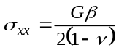 (1)
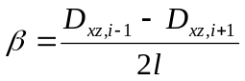 (2)
In the text of the paper, equations may be abbreviated in forms such as “Eq. (1).”
- Figures
The term “figure” denotes graphical representations including charts, graphs, drawings, photographs, etc. Figures must be inserted as close as possible to their first reference. Figures must be numbered consecutively and must have descriptive titles placed just below them. Figure captions must be typeset in 10 pt Times New Roman.
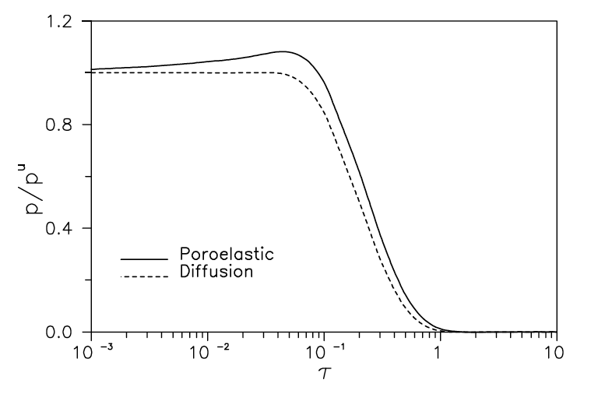
Fig. 1. Normalized pore pressure history for a pressurized cylindrical borehole, displaying the so-called Mandel-Cryer effect (Detournay and Cheng, 1993).
If photographs are being inserted, color or black and white is acceptable. Large figures or tables may straddle both columns.
- tables
In the text, tables must be inserted as close to the first point of reference as possible. Please leave some space above and below the table. Tables must be numbered sequentially in the text with Arabic numerals.
Captions must be centered above tables. Tables and table captions must be typeset in 10 pt Times New Roman font.

Table 1. Sample tables with values
 | 1 | 2
3 | 57 | 86
4 | 107 | 100
5 | 113 | 125
6 | 161 | 176

References
Citation should follow the style of Author-year with the bibliography formatted according to the style of APA (American Psychological Association). Below a few examples of how journal articles, a book, a chapter in a book and a published paper in proceedings, e.g., Hoek and
Bieniawski (1965), Haimson and Fairhurst (1967), Detournay and Cheng (1993), Crouch and Starfield (1983), Zoback et al. (1989), Hazzard et al. (2000), Ciardo and Lecampion (2021), and Madyarov et al. (2021), are formatted in the references.

In the list of references, the citations are listed in alphabetical order. References must be in 10 pt. Times New Roman.

APA 7th Edition is recommended if you choose to use the build-in style in EndNote for MS Word.

- Ciardo, F. and Lecampion, B. (2021). Aseismic slip propagation in fractured rock masses driven by pore-fuid difusion. In Proc. 55th US Rock Mechanics/Geomechanics Symposium, Houston, TX. American Rock Mechanics Association.
- Crouch, S. L. and Starfield, A. M. (1983). Boundary element methods in solid mechanics. George Allen & Unwin, London, 1st edition.
- Detournay, E. and Cheng, A. H.-D. (1993). Fundamentals of poroelasticity. In Fairhurst, C., editor, Comprehensive Rock Engineering, volume 2, pages 113–171. Pergamon, New York.
- Haimson, B. and Fairhurst, C. (1967). Initiation and extension of hydraulic fractures in rocks. SPE J., 7(03):310–318.
- Hazzard, J. F., Young, R. P., and Maxwell, S. C. (2000). Micromechanical modeling of cracking and failure in brittle rocks. J. Geophys. Res. Solid Earth, 105(B7):16,683–16,697.
- Hoek, E. and Bieniawski, Z. T. (1965). Brittle fracture propagation in rock under compression. Int. J. Fract. Mech., 1(3):137–155.
- Hoek, E. and Martin, C. D. (2014). Fracture initiation and propagation in intact rock–a review. J. Rock Mech. Geotech. Engng., 6(4):287–300.
- Madyarov, A., Prioul, R., Zutshi, A., Seprodi, N., Groves, D., Pei, J., and Wong, S.-W. (2021). Understanding the impact of completion designs on multi-stage fracturing via block test experiments. In Proc. 55th US Rock Mechanics/ Geomechanics Symposium, Houston, TX. American Rock Mechanics Association.
- Zoback, M. L., Zoback, M. D., Adams, J., Assumpcao, M., Bell, S., Bergman, E., Blümling, P., Brereton, N., Denham, D., Ding, J., Fuchs, K., Gay, N., Gregersen, S., Gupta, H., Gvishiani, A., Jacob, K., Klein, R., Knoll, P., Magee, M., Mercier, J., Müller, B., Paquin, C., Rajendran, K., Stephansson, O., Suarez, G., Suter, M., Udias, A., Xu, Z., and Zhizhin, M. (1989). Global patterns of tectonic stress. Nature, 341(6240):291–298.

