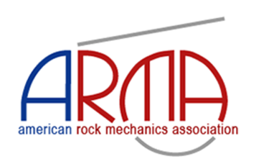

TITLE OF YOUR PROJECT
FirstName_LastName
Undergraduate Student / Master’s Student / Ph.D. Student
(Do not enter the details of your University/Institute or the Supervisor)
Abstract:
These instructions detail the recommended abstract template and are intended to demonstrate the correct formatting for ARMA SRC 2025 abstract submissions. Please note that while this sample includes highlights and other text decorations for illustration purposes, such formatting should not be used in the final submitted abstracts.
Abstracts must be between 250 and 500 words. The document should begin with the title in Arial, 16 pt font, followed by the full name of the candidate and their level of study (Bachelor, Master, or Ph.D.) in Arial, 12 pt font. The main body of the abstract must be written in Times New Roman, 12 pt font to ensure uniformity across submissions.
At the end of the abstract, include 3 to 5 keywords, each separated by a semicolon (;).
Candidates are advised not to include their university name or logo anywhere in the abstract. Additionally, figures and tables are not allowed in the abstract submission.
Keywords: keyword1; keyword2; keyword3; keyword4; keyword5

